

|  |  |
| --- | --- |
|  | **VIỆN ĐÀO TẠO QUỐC TẾ FPT**  LẬP TRÌNH VIÊN QUỐC TẾ FPT – APTECH |

****Online Insurance****

PROJECT DOCUMENTATION SEM 3

|  |  |  |
| --- | --- | --- |
| **Supervisor:** | ***Ngô Phước Nguyên*** | |
| **Semester:** | *04* | |
| **Batch No:** | T1.1908.E0 | |
| **Group No:** | *05* | |
| **Order:** | **Full name** | **Roll No.** |
| 1. | Nguyễn Văn Bình | **Student 1143789** |
| 2. | **Lê Minh Hiếu** | **Student 1141485** |
| 3. | **Phạm Khôi Minh Huân** | **Student 1140055** |
| 4. | **Trần Duy Phú** | **Student 1136505** |

**January- 2021**

 

This is to certify that

**Mr. NGUYEN VAN BINH**

**Mr. LE MINH HIEU**

**Mr. PHAM KHOI MINH HUAN**

**Mr. TRAN DUY PHU**

Have successfully Designed & Developed

**Online Isurance**

Submitted by:

**NGO PHUOC NGUYEN**

Date of Issue:

Authorized Signature:



# Acknowledgement

We would like to express our gratitude to our teachers, who teach us a lot of knowledge and practical lessons. He helped us so much in this project. Thank you!

We also would like to express our sincere thanks towards the members of the team who spent their time and knowledge in the implementation of this project.

# Problem Definition

Our client is a professional agency that provides insurance arrangements for people, motorbikes and all kinds of home insurance.

In order to ensure that our lives are increasingly improved, safe and convenient, we have incorporated online transactions to ensure the security of our customers.

**Identify The Problem:**

* Display brief information about Online Isurance.
* Display all available services of Insurance to customers.
* Customers can contact Insurance Online for all services provided through the website
* Support administrators the ability to update insurance packages quickly and accurately.
* Support customers to extend insurance

**User:**

* You can buy the insurance packages you want.
* Can contact the administrator.
* Can extend the insurance policy.
* Can view your own insurance packages.
* Can view payment email
* You can choose the payment bank

**Admin:**

* Add / update / delete / correct information about insurance packages.
* Add/update/delete/edit clients details.
* Confirm customer status
* Respond to customer feedback

# Customer Requirements Specification

**Guest:**

Inserting:

* Information about the chosen services.
* Getting contact to administrators.

Processing:

* Find information about Insurance packages.

**Admin:**

Inserting:

* Information about signing of admin.
* Information about services offered need to insert, delete or edit.
* Information about clients details needs to insert, delete or edit.

Processing:

* Inserting/Deleting/editing services offered.
* Inserting/Deleting/editing clients details.
* Reply to customer contact.

Exporting:

* Notification about inserting/deleting/editing services offered successfully or fail.
* Notification about inserting/deleting/editing clients details successfully or fail.

# Hardware/ Software Requirements

**Hardware**

* 1.0 GHz x86 Processor, Pentium III-compatible processor or faster.
* 1.4 GHz x64 Processor, AMD Opteron, AMD Athlon 64, Intel Xeon with Intel EM64T support, Intel Pentium IV with EM64T support or faster.
* 1.0 GB RAM. Recommended 2.0 GHz or faster.
* 2.0 GB of Hard disk free.
* Screen require VGA at least 1024x768 pixel resolution or higher.

**Software**

* Visual Studio .Net / ASP
* IIS server
* .Net Framework

# Task Sheet Review I

|  |  |  |  |  |  |
| --- | --- | --- | --- | --- | --- |
| Project Ref. No: 1 | Project Title:  Online Insurance Services System | Date of Preparation of Activity Plan | | | |
| No. | Task | Actual Start Date | Actual Days | Team Member Names | Status |
| 01 | Acknowledgment | Dec 28, 2020 | 4 | All Members | Completed |
| 02 | Problem Definition | All Members | Completed |
| 03 | Customer Requirement | All Members | Completed |
| 04 | Functional Logic | All Members | Completed |
| 05 | Use Case | All Members | Completed |
| 06 | Hardware/Software |  |  | All Members | Completed |

|  |  |  |
| --- | --- | --- |
|  | Prepare By: Group 5 | Approved By: Faculty |
| Date: Dec 28, 2020 | Team Leader  NGUYEN VAN BINH | Mr. NGO PHUOC NGUYEN |

# REVIEW II

1. Use case

**Admin Case**

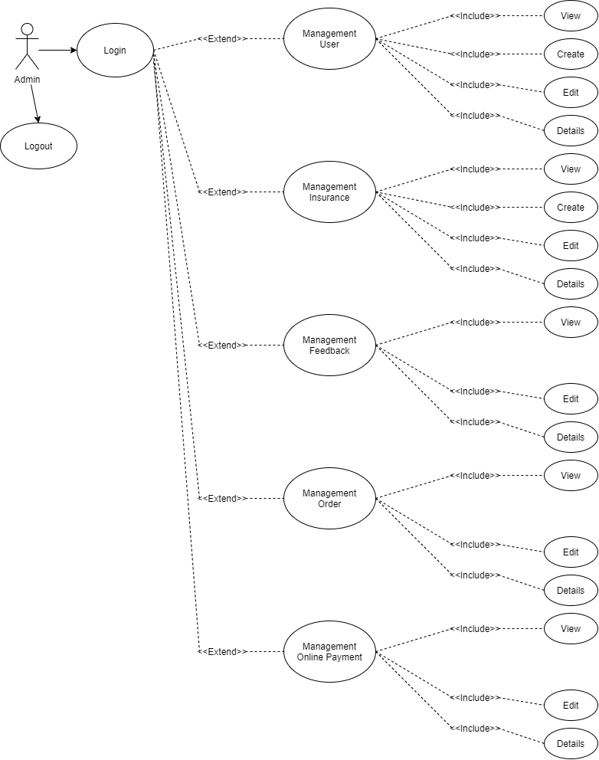

**User Case**

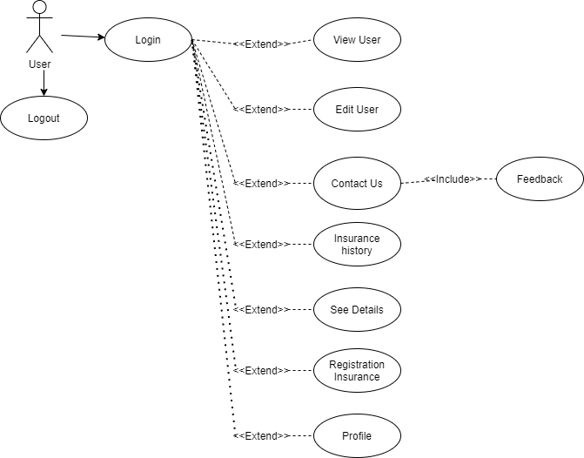

# Architecture & Design of the Project

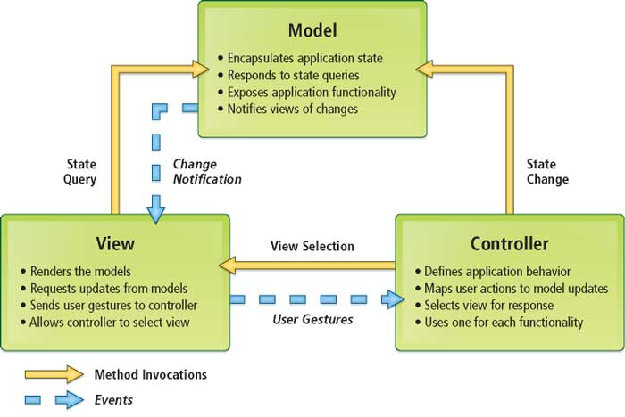

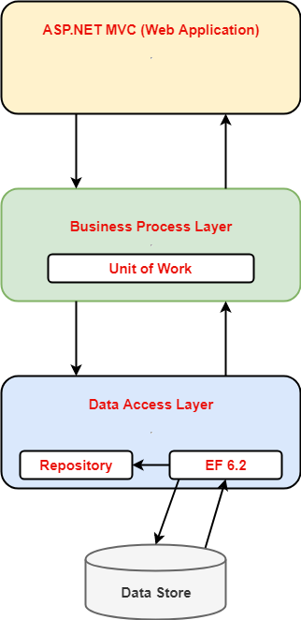

**Architecture of the Project**

1. Presentation Tier:

Is the tier in which the users interact with application. Presentation Tier contents Model, View, Controller used to receive a request and response to User.

Technology: ASP.NET MVC5, Razor, HTML, CSS, JavaScript, Ajax, JQUERY, Twitter Bootstrap

1. Business Logic Tier:

Is mainly working as the bridge between Data Tier and Presentation Tier. All the Data passes through the Business Tier before passing to the Presentation Tier.

Technology: ASP.NET

1. Data Access Tier:

Is basically the server which stores all the application’s data .Data tier contents Database Tables, Database Views and other means of storing Application Data .

Technology: SQL Server, LINQ

**Algorithms - Data Flowchart**

Symbol generates:

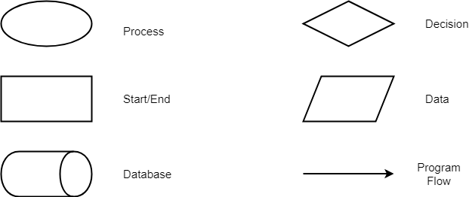

## Login function (Admin, Employee)

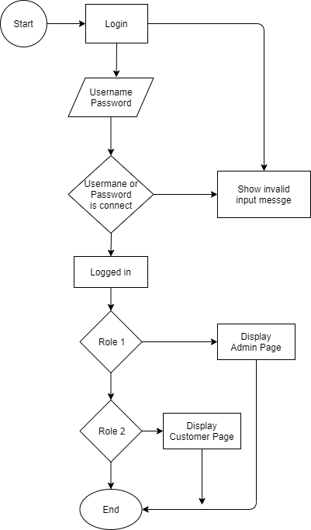

## Logout Function (Admin, Employee)

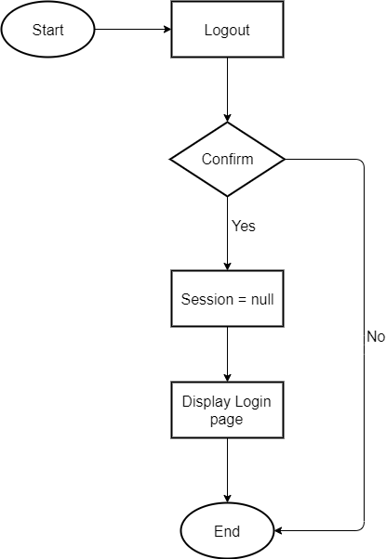

## Create Data Function (Admin Only)

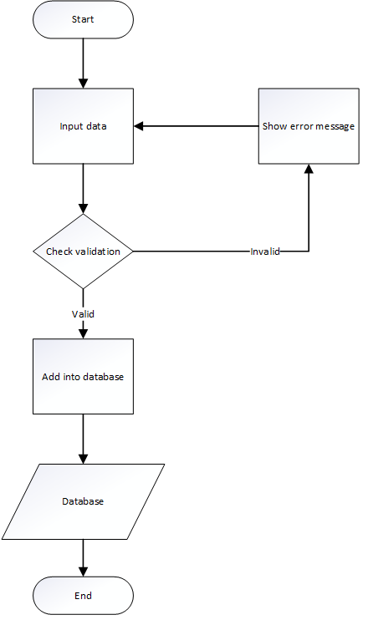

## Edit Data Function (Admin Only)

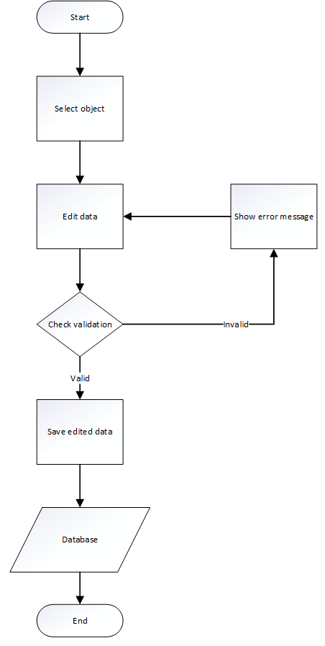

## Delete Data Function (Admin Only)

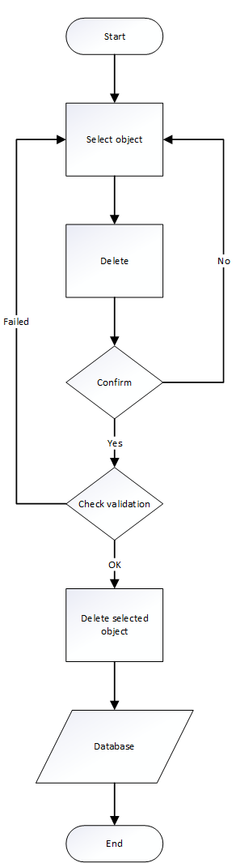

1. Data Flow Diagram

**Define:** Data Flows Diagram (DFD) describes the information flow in the system. The next step of system analysis is to consider in detail the information necessary for the implementation for functions discussed above and the one necessary for the improvement of the functions. Modelling tool frequently used for this purpose is DFD. DFD will support 4 main activities:

* **Analysis**: DFD is used to determine requirement of users.
* **Design:** DFD is used to map out plan and illustrate solution to analysis and users while designing a new system.
* **Communication:** One of the strength of DFD is its simplicity and ease to understand to analysts and users.
* **Document:** DFD is used to provide special description of requirement and system design. DFD provide an overview of key functional components of the system but it does not provide any detail on these components. We have to use other tools like database dictionary, process specification to get an idea of which information will be exchanged and how.

**The main components of Context Diagram:**

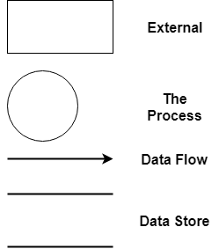

The external factors: External factors can be a person, a group of persons or an organization that are sources of information for the systems and are where system products are transferred to.

The process: Shows the common function of system

The data flow: Describe the movement of information from one part of the system to another.

The data store: The Data Store is used to model a collection of data packets at rest. A store is represented graphically by two parallel lines. The name of a Data Store that identifies the store is the plural of the name of the packets that are carried by flows into and out of the Data Store.

**1 Admin**

Admin

tbUser

**1.1 User Offered Manager**

**1.2 Insurance Offered Manager**

Admin

tbInsurance

**1.3 Clients Manager**

Admin

tbClients

## **2 Entities and Properties**

* 1. **User Entity & Properties**

%3CmxGraphModel%3E%3Croot%3E%3CmxCell%20id%3D%220%22%2F%3E%3CmxCell%20id%3D%221%22%20parent%3D%220%22%2F%3E%3CmxCell%20id%3D%222%22%20value%3D%22%22%20style%3D%22endArrow%3Dnone%3Bdashed%3D1%3Bhtml%3D1%3BentryX%3D0%3BentryY%3D0.5%3BentryDx%3D0%3BentryDy%3D0%3B%22%20edge%3D%221%22%20parent%3D%221%22%3E%3CmxGeometry%20width%3D%2250%22%20height%3D%2250%22%20relative%3D%221%22%20as%3D%22geometry%22%3E%3CmxPoint%20x%3D%22370%22%20y%3D%22485%22%20as%3D%22sourcePoint%22%2F%3E%3CmxPoint%20x%3D%22400%22%20y%3D%22485%22%20as%3D%22targetPoint%22%2F%3E%3C%2FmxGeometry%3E%3C%2FmxCell%3E%3C%2Froot%3E%3C%2FmxGraphModel%3E

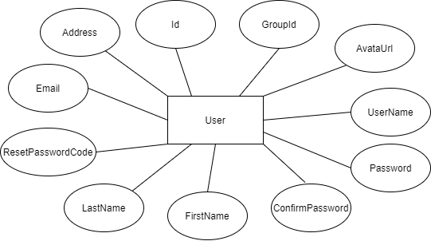

* 1. **Insurance Entity & Properties**

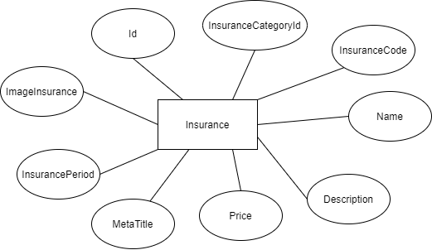

* 1. **Contact Entity & Properties**

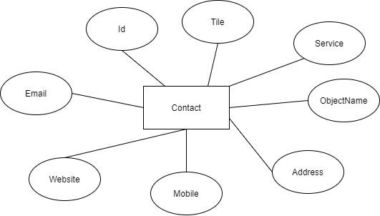

* 1. **Feedback Entity & Properties**

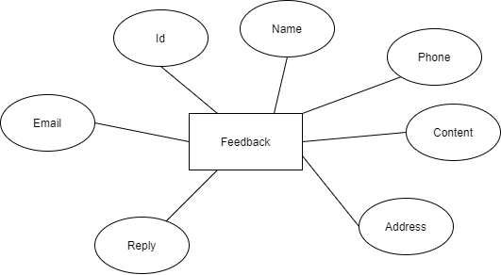

* 1. **Oder Entity & Properties**

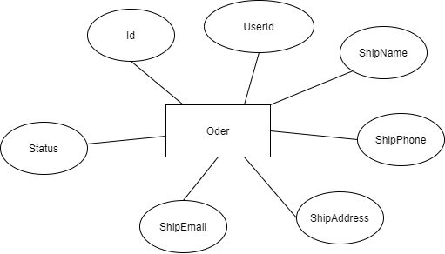

# Task sheet review 2

|  |  |  |  |  |  |
| --- | --- | --- | --- | --- | --- |
| Project Ref. No: 2 | Project Title:  Online Insurance Services System | Date of Preparation of Activity Plan | | | |
| No. | Task | Actual Start Date | Actual Days | Team Member Name | Status |
| 01 | Architecture & Design of the Project | Dec 28, 2020 | 6 | All Members | Completed |
| 02 | Algorithms - Data Flowchart | Nguyen Van Binh | Completed |
| 03 | Data Flow Diagram | Le Minh Hieu | Completed |
| Pham Khoi Huan | Completed |
| 04 | ERD | Tran Duy Phu | Completed |

|  |  |  |
| --- | --- | --- |
|  | Prepare By: Group 5 | Approved By: Faculty |
| Date: Jan 07, 2020 | Team Leader  Nguyen Van Binh | Mr. NGO PHUOC NGUYEN |

REVIEW III

1. **Database Design**
2. **Database Design Diagram**

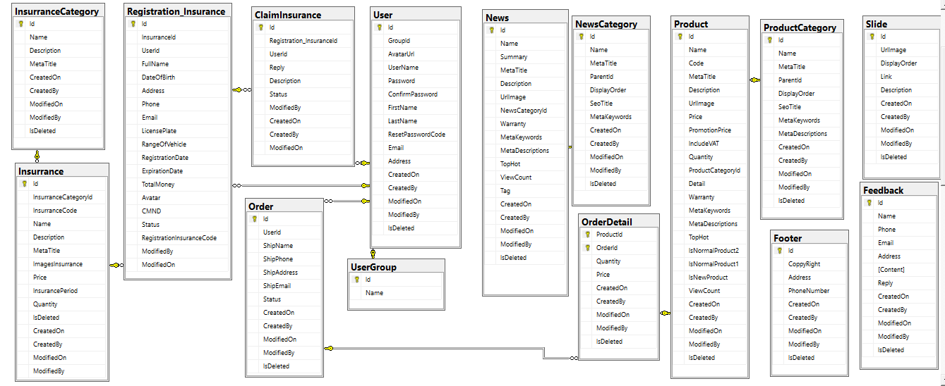

1. **Database Structure**

**2.1. Table User**

|  |  |  |  |  |  |  |
| --- | --- | --- | --- | --- | --- | --- |
| Field Name | Data Type | Null | Default | Key | Field-Ref | Description |
| Id | uniqueidentifier | No |  | PK | Identity(1,1) | Id |
| GroupId | varchar(50) | No |  |  |  | GroupId |
| AvatarUrl | nvarchar(256) | No |  |  |  | AvatarUrl |
| UserName | varchar(50) | No |  |  |  | UserName |
| Password | varchar(50) | No |  |  |  | Password |
| ConfirmPassword | varchar(50) | No |  |  |  | ConfirmPassword |
| FirstName | nvarchar(100) | No |  |  |  | FirstName |
| LastName | nvarchar(100) | No |  |  |  | LastName |
| ResetPasswordCode | nvarchar(100) | No |  |  |  | ResetPasswordCode |
| Email | varchar(256) | No |  |  |  | Email |
| Address | nvarchar(MAX) | No |  |  |  | Address |
| CreatedOn | datetimeoffset(7) | No |  |  |  | CreatedOn |
| CreatedBy | nvarchar(256) | No |  |  |  | CreatedBy |
| ModifiedOn | datetimeoffset(7) | No |  |  |  | ModifiedOn |
| ModifiedBy | nvarchar(256) | No |  |  |  | ModifiedBy |
| IsDeleted | bit | No |  |  |  | IsDeleted |

* 1. **Table ClaimInsurance**

|  |  |  |  |  |  |  |
| --- | --- | --- | --- | --- | --- | --- |
| Field Name | Data Type | Null | Default | Key | Field-Ref | Description |
| Id | uniqueidentifier | No |  | PK | Identity(1,1) | Id |
| UserId | uniqueidentifier | No |  |  |  | UserId |
| Registration_InsuranceId | nvarchar(300) | No |  |  |  | Registration_InsuranceId |
| Reply | nvarchar(MAX) | No |  |  |  | Reply |
| Description | nvarchar(MAX) | No |  |  |  | Description |
| Status | nvarchar(255) | No |  |  |  | Status |
| ModifiedBy | nvarchar(256) |  |  |  |  | ModifiedBy |
| CreatedOn | datetimeoffset(7) | No |  |  |  | CreatedOn |
| CreatedBy | nvarchar(256) | No |  |  |  | CreatedBy |
| ModifiedOn | datetimeoffset(7) | No |  |  |  | ModifiedOn |

* 1. **Table Contact**

|  |  |  |  |  |  |  |
| --- | --- | --- | --- | --- | --- | --- |
| Field Name | Data Type | Null | Default | Key | Field-Ref | Description |
| Id | int | No |  | PK | Identity(1,1) | Id |
| Title | nvarchar(256) | No |  |  |  | Title |
| ServiceTypeDescription | nvarchar(500) | No |  |  |  | ServiceTypeDescription |
| ObjectName | nvarchar(256) | No |  |  |  | ObjectName |
| Address | nvarchar(256) | No |  |  |  | Address |
| Mobile | varchar(20) | No |  |  |  | Mobile |
| Website | varchar(256) | No |  |  |  | Website |
| Email | varchar(256) | No |  |  |  | Email |
| CreatedOn | datetimeoffset(7) | No |  |  |  | CreatedOn |
| CreatedBy | nvarchar(256) | No |  |  |  | CreatedBy |
| ModifiedOn | datetimeoffset(7) | No |  |  |  | ModifiedOn |
| ModifiedBy | nvarchar(256) | No |  |  |  | ModifiedBy |
| IsDeleted | bit | No |  |  |  | IsDeleted |

* 1. **Table Feedback**
  2. **Table Insurrance**

|  |  |  |  |  |  |  |
| --- | --- | --- | --- | --- | --- | --- |
| Field Name | Data Type | Null | Default | Key | Field-Ref | Description |
| Id | uniqueidentifier | No |  | PK | Identity(1,1) | Id |
| Name | nvarchar(256) | No |  |  |  | Name |
| Phone | varchar(50) | No |  |  |  | Phone |
| Email | varchar(256) | No |  |  |  | Email |
| Address | nvarchar(256) |  |  |  |  | Address |
| [Content] | nvarchar(MAX) |  |  |  |  | [Content] |
| Reply | nvarchar(MAX) |  |  |  |  | Reply |
| CreatedOn | datetimeoffset(7) | No |  |  |  | CreatedOn |
| CreatedBy | nvarchar(256) | No |  |  |  | CreatedBy |
| ModifiedOn | datetimeoffset(7) | No |  |  |  | ModifiedOn |
| ModifiedBy | nvarchar(256) | No |  |  |  | ModifiedBy |
| IsDeleted | bit | No |  |  |  | IsDeleted |

|  |  |  |  |  |  |  |
| --- | --- | --- | --- | --- | --- | --- |
| Field Name | Data Type | Null | Default | Key | Field-Ref | Description |
| Id | uniqueidentifier | No |  | PK | Identity(1,1) | Id |
| InsurranceCategoryId | uniqueidentifier | No |  |  |  | InsurranceCategoryId |
| InsurranceCode | nvarchar(50) | No |  |  |  | InsurranceCode |
| Name | nvarchar(250) | No |  |  |  | Name |
| Description | nvarchar(10) | No |  |  |  | Description |
| MetaTitle | nvarchar(250) | No |  |  |  | MetaTitle |
| ImagesInsurrance | nvarchar(250) | No |  |  |  | ImagesInsurrance |
| Price | decimal(18, 0) | No |  |  |  | Price |
| InsurancePeriod | nvarchar(255) | No |  |  |  | InsurancePeriod |
| Quantity | int | No |  |  |  | Quantity |
| CreatedOn | datetimeoffset(7) | No |  |  |  | CreatedOn |
| CreatedBy | nvarchar(256) | No |  |  |  | CreatedBy |
| ModifiedOn | datetimeoffset(7) | No |  |  |  | ModifiedOn |
| ModifiedBy | nvarchar(256) | No |  |  |  | ModifiedBy |
| IsDeleted | bit | No |  |  |  | IsDeleted |

* 1. **Table Order**

|  |  |  |  |  |  |  |
| --- | --- | --- | --- | --- | --- | --- |
| Field Name | Data Type | Null | Default | Key | Field-Ref | Description |
| Id | uniqueidentifier | No |  | PK | Identity(1,1) | Id |
| UserId | uniqueidentifier | No |  |  |  | UserId |
| ShipName | nvarchar(256) | No |  |  |  | ShipName |
| ShipPhone | nvarchar(50) | No |  |  |  | ShipPhone |
| ShipAddress | nvarchar(256) | No |  |  |  | ShipAddress |
| ShipEmail | varchar(256) | No |  |  |  | ShipEmail |
| Status | bit |  |  |  |  | Status |
| CreatedOn | datetimeoffset(7) | No |  |  |  | CreatedOn |
| CreatedBy | nvarchar(256) | No |  |  |  | CreatedBy |
| ModifiedOn | datetimeoffset(7) | No |  |  |  | ModifiedOn |
| ModifiedBy | nvarchar(256) | No |  |  |  | ModifiedBy |
| IsDeleted | bit | No |  |  |  | IsDeleted |

* 1. **Table OrderDetail**

|  |  |  |  |  |  |  |
| --- | --- | --- | --- | --- | --- | --- |
| Field Name | Data Type | Null | Default | Key | Field-Ref | Description |
| ProductId | uniqueidentifier | No |  | PK | Identity(1,1) | ProductId |
| OrderId | uniqueidentifier | No |  |  |  | OrderId |
| Quantity | int | No |  |  |  | Quantity |
| Price | decimal(18, 0) | No |  |  |  | Price |
| CreatedOn | datetimeoffset(7) | No |  |  |  | CreatedOn |
| CreatedBy | nvarchar(256) | No |  |  |  | CreatedBy |
| ModifiedOn | datetimeoffset(7) | No |  |  |  | ModifiedOn |
| ModifiedBy | nvarchar(256) | No |  |  |  | ModifiedBy |
| IsDeleted | bit | No |  |  |  | IsDeleted |

* 1. **Table Product**

|  |  |  |  |  |  |  |
| --- | --- | --- | --- | --- | --- | --- |
| Field Name | Data Type | Null | Default | Key | Field-Ref | Description |
| Id | uniqueidentifier | No |  | PK | Identity(1,1) | Id |
| Name | nvarchar(256) | No |  |  |  | Name |
| Code | int | No |  |  |  | Code |
| Meta Title | nvarchar(256) | No |  |  |  | Meta Title |
| Description | nvarchar(MAX) | No |  |  |  | Description |
| UrlImage | nvarchar(256) | No |  |  |  | UrlImage |
| Price | decimal(18, 0) | No |  |  |  | Price |
| PromotionPrice | decimal(18, 0) | No |  |  |  | PromotionPrice |
| IncludeVAT | bit | No |  |  |  | IncludeVAT |
| Quantity | int | No |  |  |  | Quantity |
| ProductCategoryId | uniqueidentifier | No |  |  |  | ProductCategoryId |
| Detail | ntext | No |  |  |  | Detail |
| Warranty | int | No |  |  |  | Warranty |
| MetaKeywords | nvarchar(256) | No |  |  |  | MetaKeywords |
| MetaDescriptions | nvarchar(256) | No |  |  |  | MetaDescriptions |
| TopHot | bit | No |  |  |  | TopHot |
| IsNormalProduct2 | bit | No |  |  |  | IsNormalProduct2 |
| IsNormalProduct1 | bit | No |  |  |  | IsNormalProduct1 |
| IsNewProduct | bit | No |  |  |  | IsNewProduct |
| ViewCount | bit | No |  |  |  | ViewCount |
| CreatedBy | nvarchar(256) | No |  |  |  | CreatedBy |
| ModifiedOn | datetimeoffset(7) | No |  |  |  | ModifiedOn |
| ModifiedBy | nvarchar(256) | No |  |  |  | ModifiedBy |
| IsDeleted | bit | No |  |  |  | IsDeleted |

* 1. **Table ProductCategory**

|  |  |  |  |  |  |  |
| --- | --- | --- | --- | --- | --- | --- |
| Field Name | Data Type | Null | Default | Key | Field-Ref | Description |
| Id | uniqueidentifier | No |  | PK | Identity(1,1) | Id |
| Name | nvarchar(256) | No |  |  |  | Name |
| Meta Title | nvarchar(256) | No |  |  |  | Meta Title |
| ParentId | int | No |  |  |  | ParentId |
| DisplayOrder | int | No |  |  |  | DisplayOrder |
| SeoTitle | nvarchar(256) | No |  |  |  | SeoTitle |
| MetaKeywords | nvarchar(256) | No |  |  |  | MetaKeywords |
| MetaDescriptions | nvarchar(256) | No |  |  |  | MetaDescriptions |
| CreatedOn | datetimeoffset(7) | No |  |  |  | CreatedOn |
| CreatedBy | nvarchar(256) | No |  |  |  | CreatedBy |
| ModifiedOn | datetimeoffset(7) | No |  |  |  | ModifiedOn |
| ModifiedBy | nvarchar(256) | No |  |  |  | ModifiedBy |
| IsDeleted | bit | No |  |  |  | IsDeleted |

* 1. **Table Registration_Insurance**

|  |  |  |  |  |  |  |
| --- | --- | --- | --- | --- | --- | --- |
| Field Name | Data Type | Null | Default | Key | Field-Ref | Description |
| Id | uniqueidentifier | No |  | PK | Identity(1,1) | Id |
| InsurranceId | uniqueidentifier | No |  |  |  | InsurranceId |
| UserId | uniqueidentifier | No |  |  |  | UserId |
| FullName | nvarchar(255) | No |  |  |  | FullName |
| DateOfBirth | date |  |  |  |  | DateOfBirth |
| Address | nvarchar(255) |  |  |  |  | Address |
| Phone | nvarchar(255) |  |  |  |  | Phone |
| Email | nvarchar(255) |  |  |  |  | Email |
| LicensePlate | nvarchar(255) |  |  |  |  | LicensePlate |
| RangeOfVehicle | nvarchar(255) |  |  |  |  | RangeOfVehicle |
| RegistrationDate | datetime |  |  |  |  | RegistrationDate |
| ExpirationDate | datetime |  |  |  |  | ExpirationDate |
| TotalMoney | int |  |  |  |  | TotalMoney |
| Avatar | nvarchar(255) |  |  |  |  | Avatar |
| CMND | nvarchar(255) |  |  |  |  | CMND |
| Status | nvarchar(255) |  |  |  |  | Status |
| RegistrationInsuranceCode | nvarchar(50) |  |  |  |  | RegistrationInsuranceCode |
| ModifiedBy | nvarchar(256) |  |  |  |  | ModifiedBy |
| ModifiedOn | datetimeoffset(7) |  |  |  |  | ModifiedOn |

# II – GUI Design

1. **Admin Page**

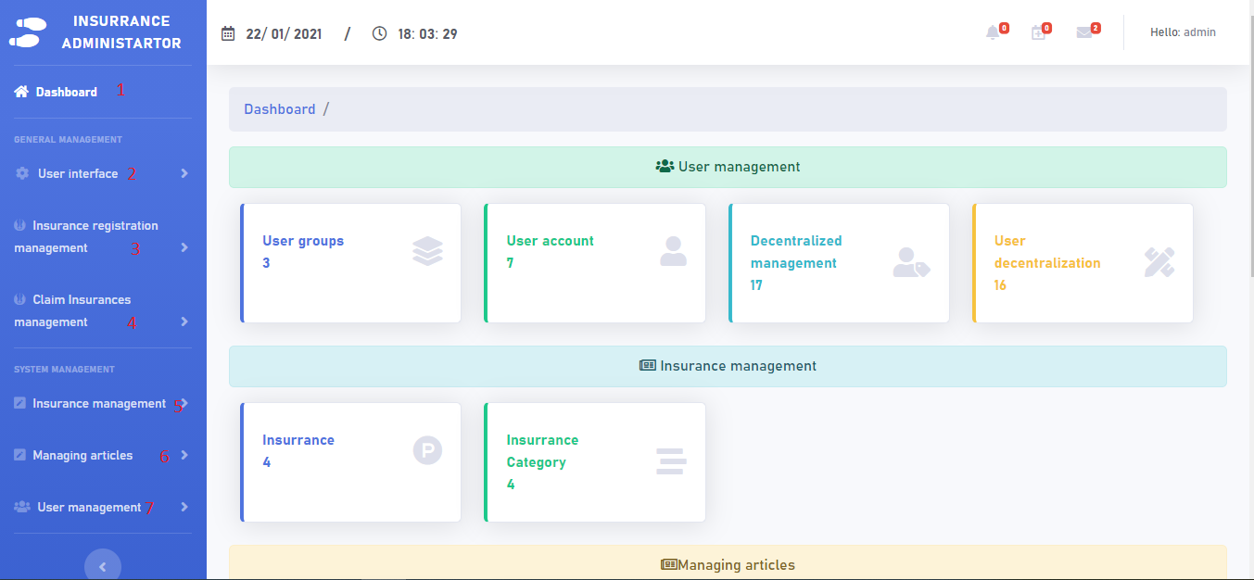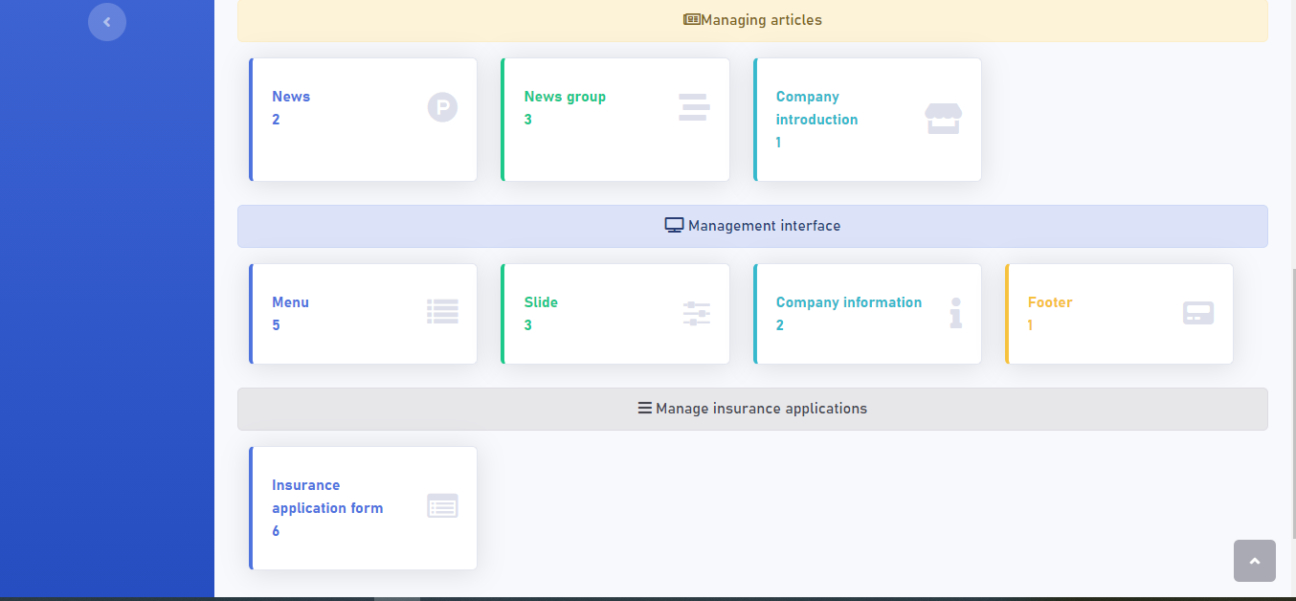

|  |  |  |  |  |  |  |
| --- | --- | --- | --- | --- | --- | --- |
| Admin | | | | | | |
| No. | **Name** | **Type** | **Validation** | **Event** | **Description** | **Status** |
| 1 | Dashboard | Hyperlink |  | Click | Dashboard | Enable |
| 2 | User Interface | Hyperlink |  | Click | Show User Interface list | Enable |
| 3 | Insurance registration management | Hyperlink |  | Click | Show Insurance management list | Enable |
| 4 | Claim Insurance management | Hyperlink |  | Click | Show Claim Insurance management list | Enable |
| 5 | Insurance managemant | Hyperlink |  | Click | Show Insurance managemant list | Enable |
| 6 | Managing articles | Hyperlink |  | Click | Show Managing articles list | Enable |
| 7 | User management | Hyperlink |  | Click | Show User management list | Enable |

* 1. **Insurance registration management**

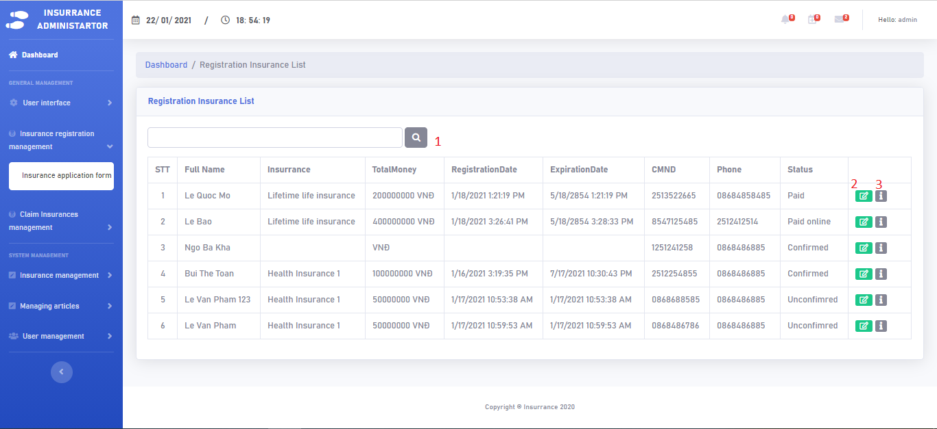

|  |  |  |  |  |  |  |
| --- | --- | --- | --- | --- | --- | --- |
| Insurance management | | | | | | |
| No. | **Name** | **Type** | **Validation** | **Event** | **Description** | **Status** |
| 1 | Search | Text | Search all | Click | Show a client | Enable |
| 2 | Edit | Hyperlink |  | Click | Edit a client Status | Enable |
| 3 | Details | Hyperlink |  | Click | Show a client detail | Enable |

**A . Edit Status**

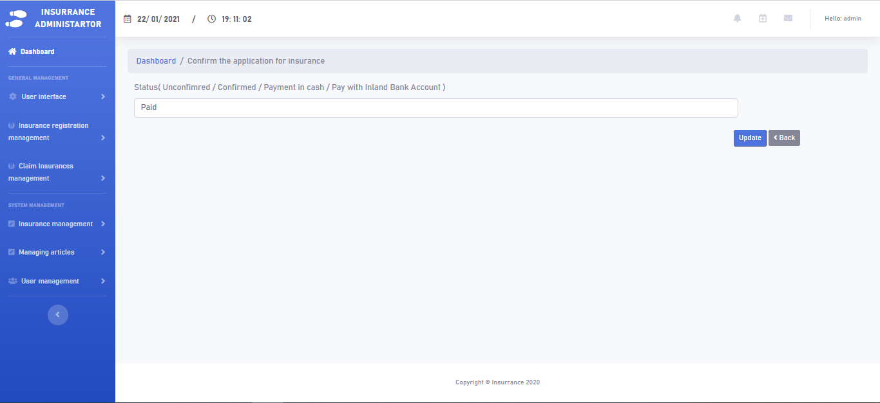

**B. Detail Insurance client**

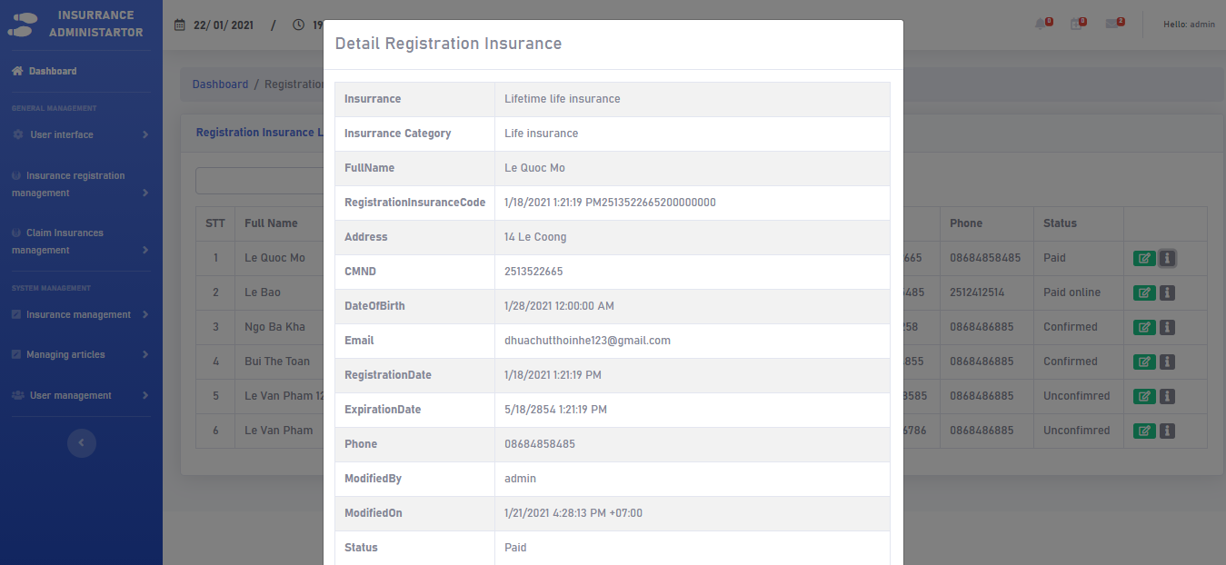

* 1. **Claim Insurance management**

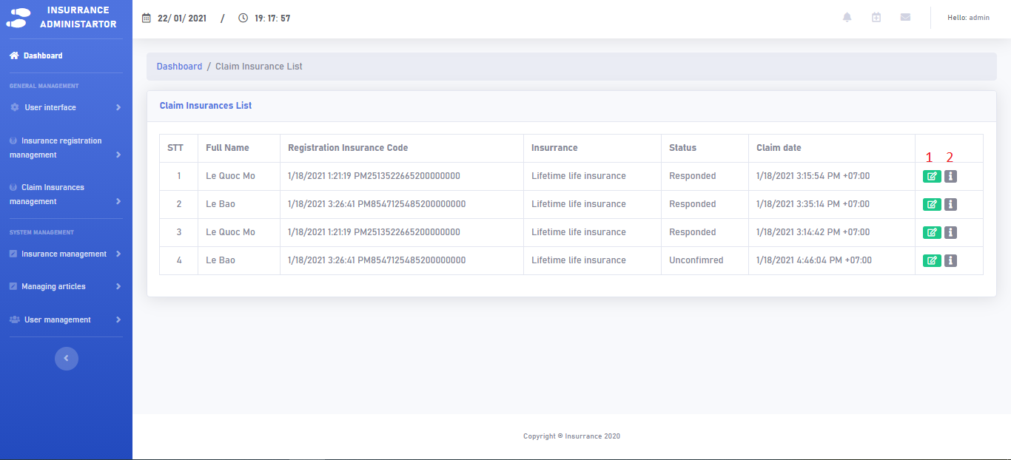

|  |  |  |  |  |  |  |
| --- | --- | --- | --- | --- | --- | --- |
| Claim management | | | | | | |
| No. | **Name** | **Type** | **Validation** | **Event** | **Description** | **Status** |
| 1 | Reply | Hyperlink |  | Click | Reply a client | Enable |
| 2 | Details | Hyperlink |  | Click | Show a client reply | Enable |

1. **Reply**

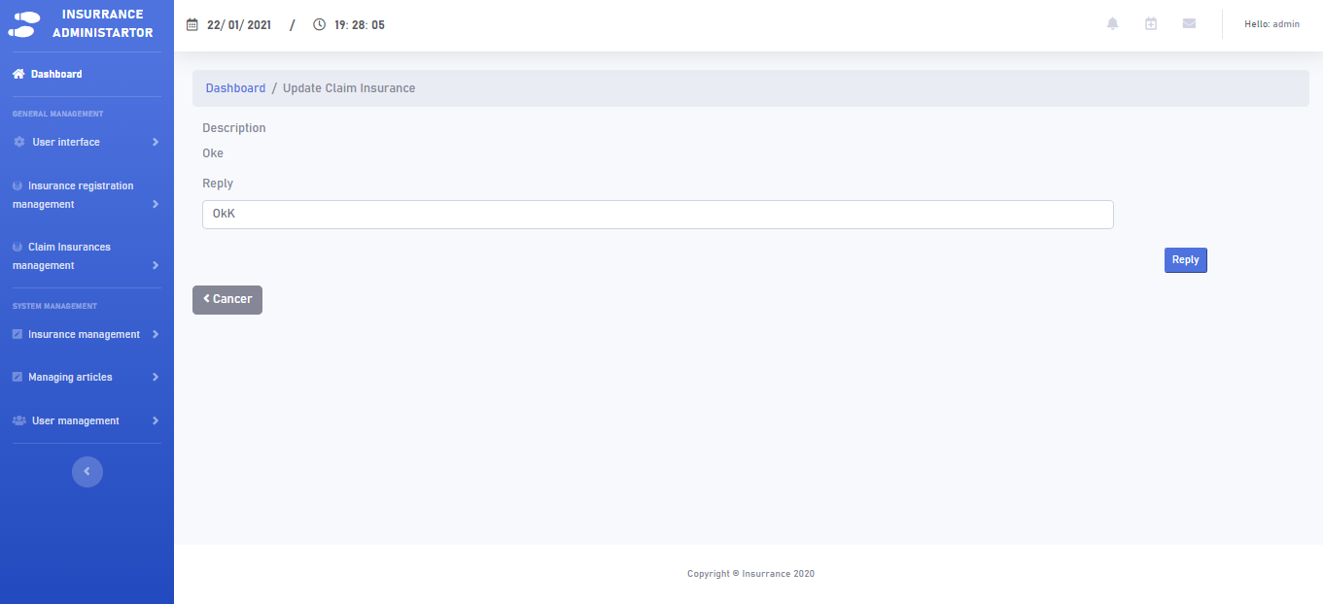

1. **Detail Claim Insurance**

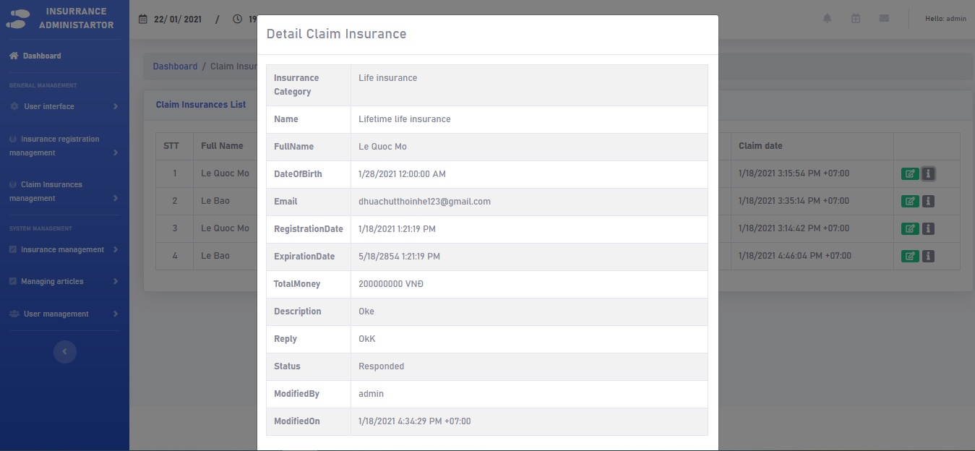

* 1. **Insurance management**

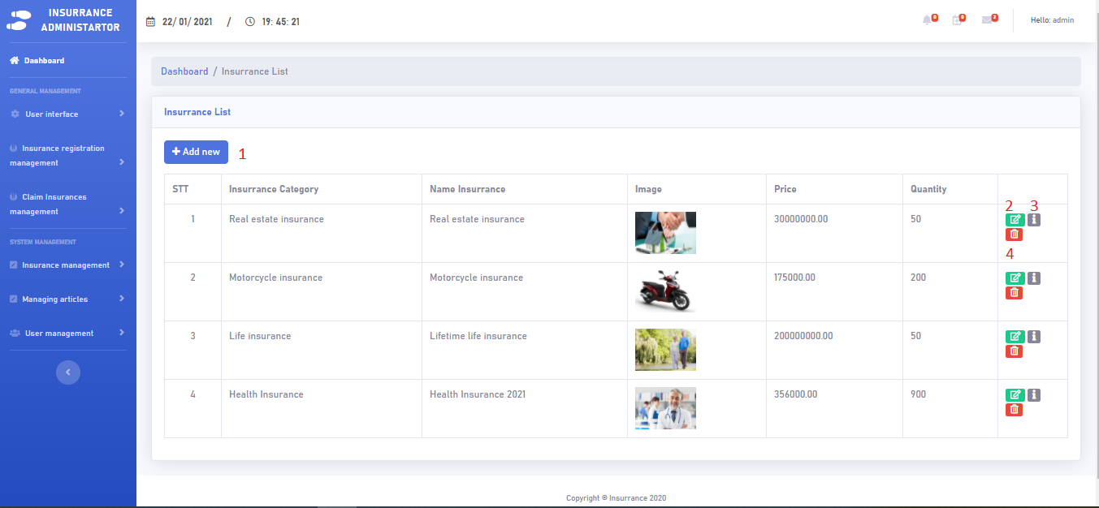

|  |  |  |  |  |  |  |
| --- | --- | --- | --- | --- | --- | --- |
| Insurance management | | | | | | |
| No. | **Name** | **Type** | **Validation** | **Event** | **Description** | **Status** |
| 1 | Create New | Hyperlink |  | Click | Create new Insurance | Enable |
| 2 | Edit | Hyperlink |  | Click | Edit insurance details | Enable |
| 3 | Details | Hyperlink |  | Click | Show insurance detail | Enable |
| 4 | Delete | Hyperlink | Display promp message. Click “Yes” to proceed, “No” to cancel. | Click | Delete insurance | Enable |

1. **Create New**

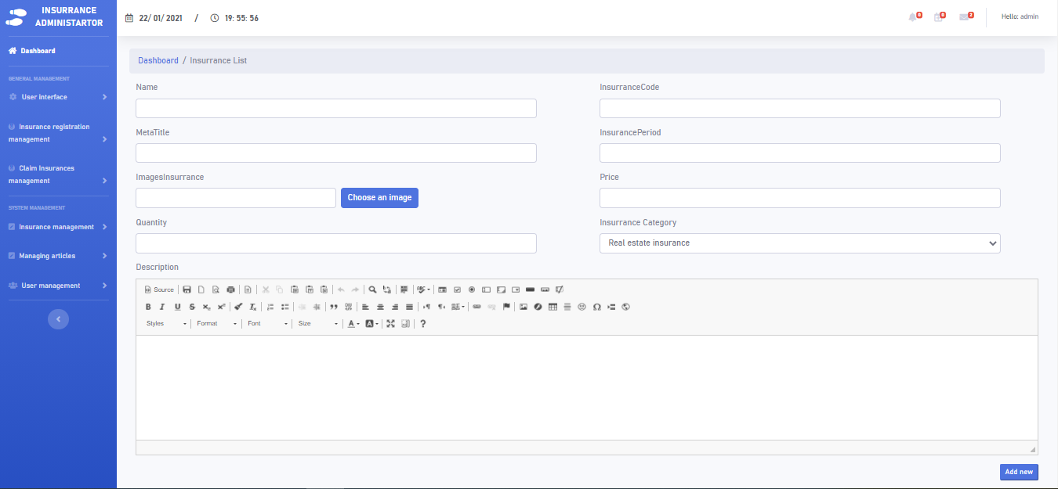

1. **Edit**

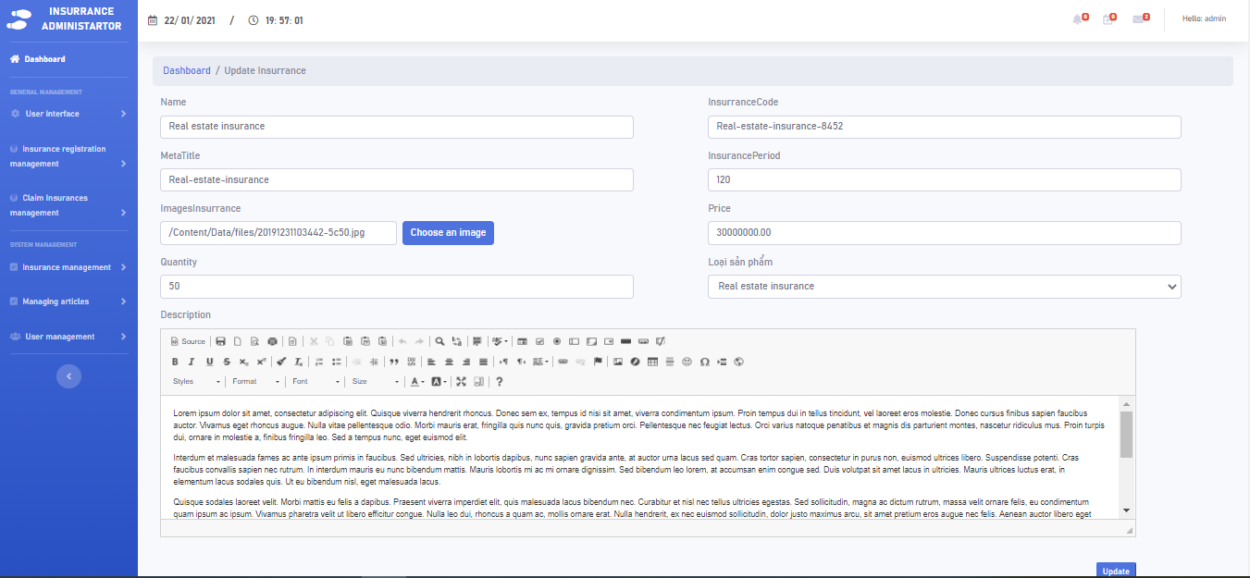

* 1. **Managing articles**

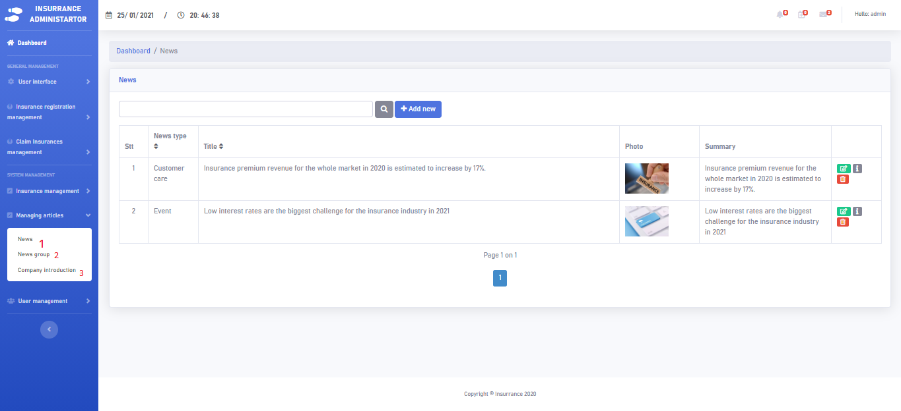

|  |  |  |  |  |  |  |
| --- | --- | --- | --- | --- | --- | --- |
| Managing articles | | | | | | |
| No. | **Name** | **Type** | **Validation** | **Event** | **Description** | **Status** |
| 1 | Create New/Edit/Delete/Details | Hyperlink |  | Click | Create New/Edit/Delete/Details Insurance | Enable |
| 2 | Create New/Edit/Delete/Details Group | Hyperlink |  | Click | Create New/Edit/Delete/Details Group | Enable |
| 3 | Create New/Edit/Delete/Details Company Introduction | Hyperlink |  | Click | Create New/Edit/Delete/Details Company Introduction | Enable |

* 1. **User management**

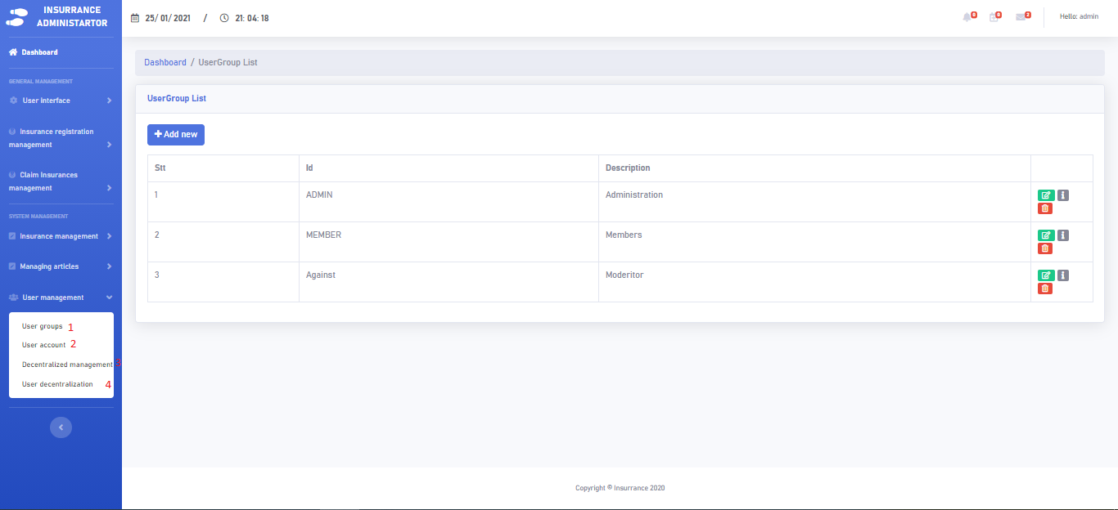

|  |  |  |  |  |  |  |
| --- | --- | --- | --- | --- | --- | --- |
| User Management | | | | | | |
| No. | **Name** | **Type** | **Validation** | **Event** | **Description** | **Status** |
| 1 | User group | Hyperlink |  | Click | Show User group | Enable |
| 2 | User accoun | Hyperlink |  | Click | Show User account | Enable |
| 3 | Decentralized management | Hyperlink |  | Click | Show Decentralized management | Enable |
| 4 | User decentralization | Hyperlink |  | Click | Show User decentralization | Enable |

* + 1. **User group**

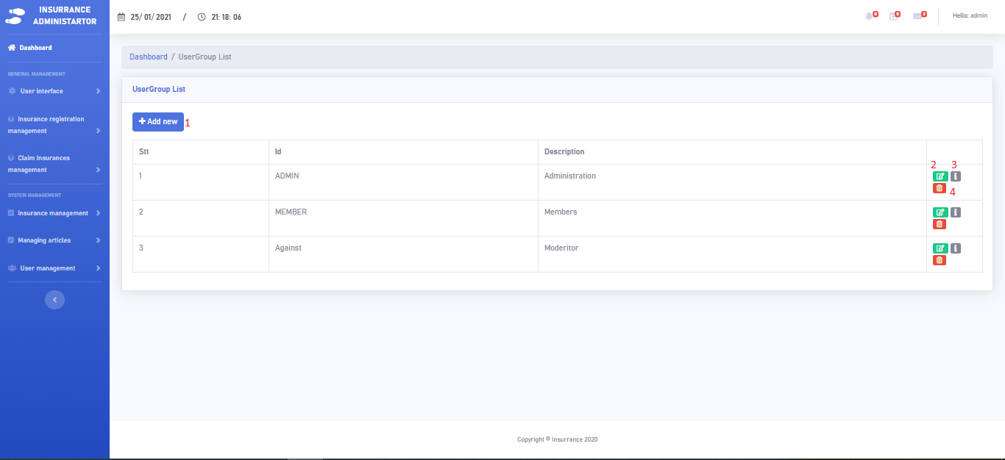

|  |  |  |  |  |  |  |
| --- | --- | --- | --- | --- | --- | --- |
| User group | | | | | | |
| No. | **Name** | **Type** | **Validation** | **Event** | **Description** | **Status** |
| 1 | Create New | Hyperlink |  | Click | Create new User | Enable |
| 2 | Edit | Hyperlink |  | Click | Edit User | Enable |
| 3 | Details | Hyperlink |  | Click | Show User detail | Enable |
| 4 | Delete | Hyperlink | Display promp message. Click “Yes” to proceed, “No” to cancel. | Click | Delete User | Enable |

* + 1. **User account**

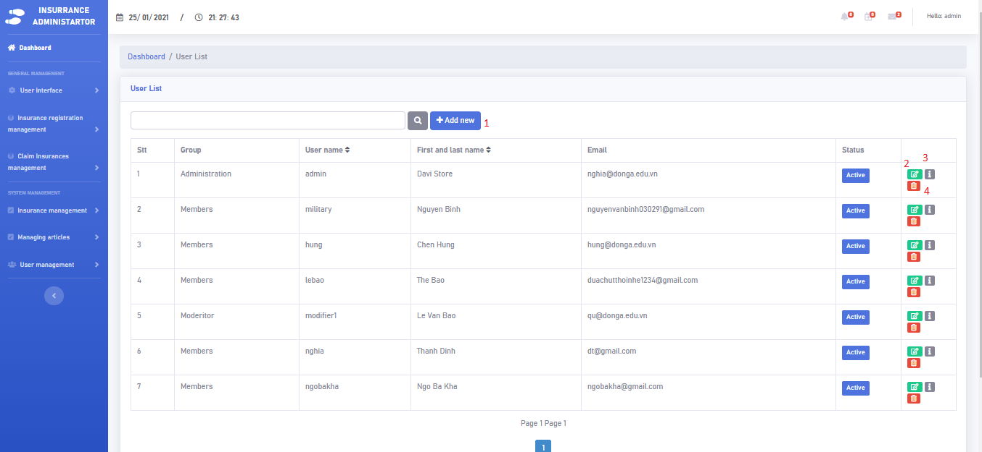

|  |  |  |  |  |  |  |
| --- | --- | --- | --- | --- | --- | --- |
| User account | | | | | | |
| No. | **Name** | **Type** | **Validation** | **Event** | **Description** | **Status** |
| 1 | Create New | Hyperlink |  | Click | Create new account | Enable |
| 2 | Edit | Hyperlink |  | Click | Edit  account | Enable |
| 3 | Details | Hyperlink |  | Click | Show account detail | Enable |
| 4 | Delete | Hyperlink | Display promp message. Click “Yes” to proceed, “No” to cancel. | Click | Delete account | Enable |

* + 1. **Decentralized management**

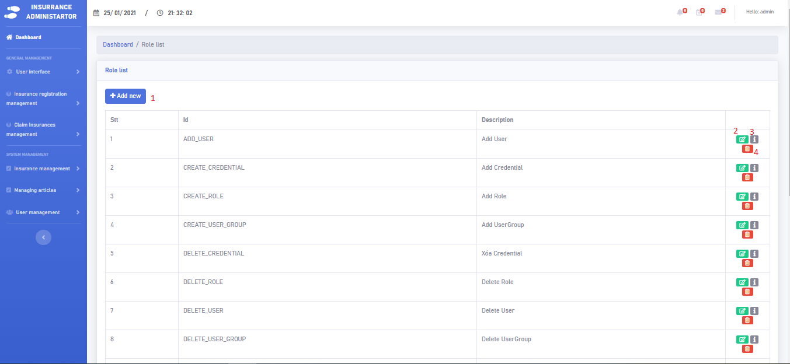

|  |  |  |  |  |  |  |
| --- | --- | --- | --- | --- | --- | --- |
| Decentralized management | | | | | | |
| No. | **Name** | **Type** | **Validation** | **Event** | **Description** | **Status** |
| 1 | Create New | Hyperlink |  | Click | Create new  Decentralized | Enable |
| 2 | Edit | Hyperlink |  | Click | Edit  Decentralized | Enable |
| 3 | Details | Hyperlink |  | Click | Show Decentralized detail | Enable |
| 4 | Delete | Hyperlink | Display promp message. Click “Yes” to proceed, “No” to cancel. | Click | Delete Decentralized | Enable |

* + 1. **User decentralization**

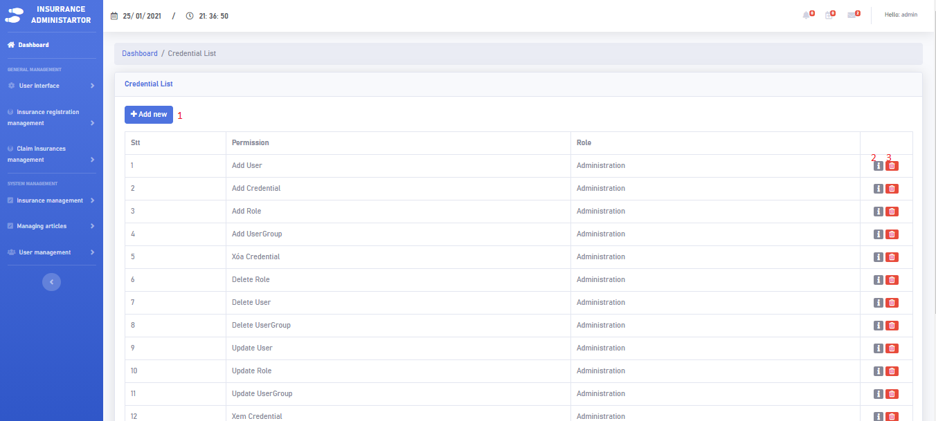

|  |  |  |  |  |  |  |
| --- | --- | --- | --- | --- | --- | --- |
| Decentralized management | | | | | | |
| No. | **Name** | **Type** | **Validation** | **Event** | **Description** | **Status** |
| 1 | Create New | Hyperlink |  | Click | Create new  decentralization | Enable |
| 2 | Details | Hyperlink |  | Click | Show decentralization detail | Enable |
| 3 | Details | Hyperlink | Display promp message. Click “Yes” to proceed, “No” to cancel. | Click | Show decentralization detail | Enable |

1. **Client:**

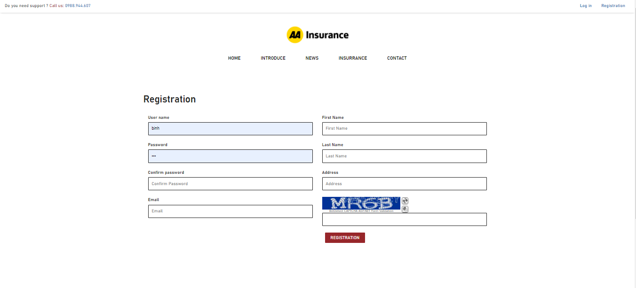

|  |  |  |  |  |  |  |
| --- | --- | --- | --- | --- | --- | --- |
| Registration | | | | | | |
| No. | **Name** | **Type** | **Validation** | **Event** | **Description** | **Status** |
| 1 | User Name | Textbox | Must have 5-30 normal characters. | Click | Input name | Enable |
| 2 | First Name | Textbox | Must have 5-30 normal characters | Click | Input First Name | Enable |
| 3 | Last Name | Textbox | Must have 5-30 normal characters | Click | Input Last Name | Enable |
| 4 | Password | Textbox | Not null | Click | Input Password | Enable |
| 5 | Confirm Password | Textbox | Not null | Click | Input Confirm Password | Enable |
| 6 | Address | Textbox | Not null | Click | Input Address | Enable |
| 7 | Email | Textbox | Must have 5-30 normal characters | Click | Input Email | Enable |
| 8 | Captcha | Textbox | Not null | Click | Input Captcha | Enable |

* 1. **Home**





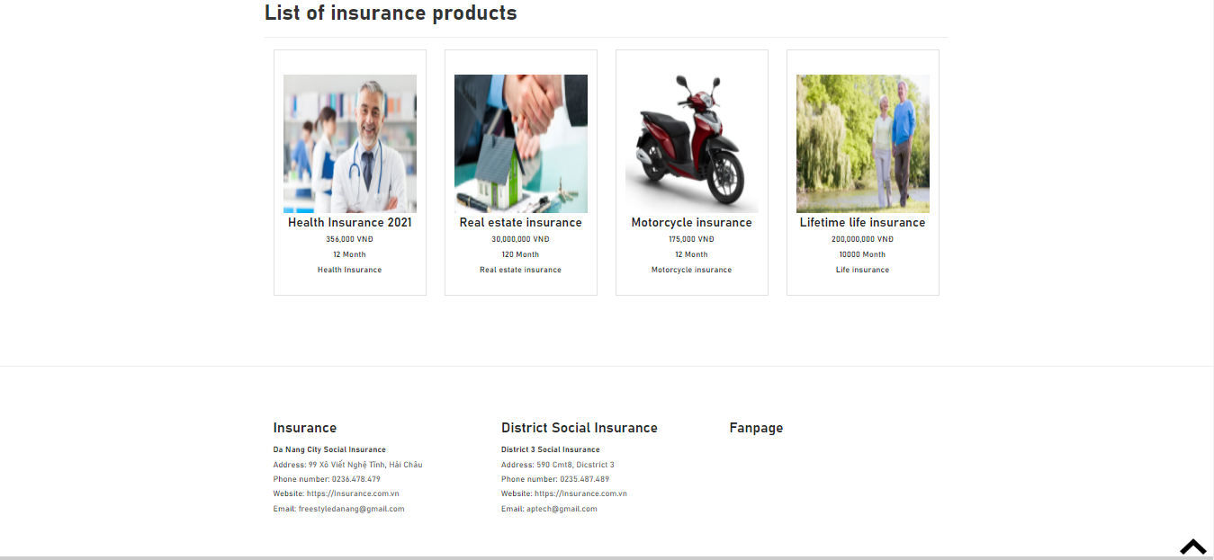

* 1. **Introduce**

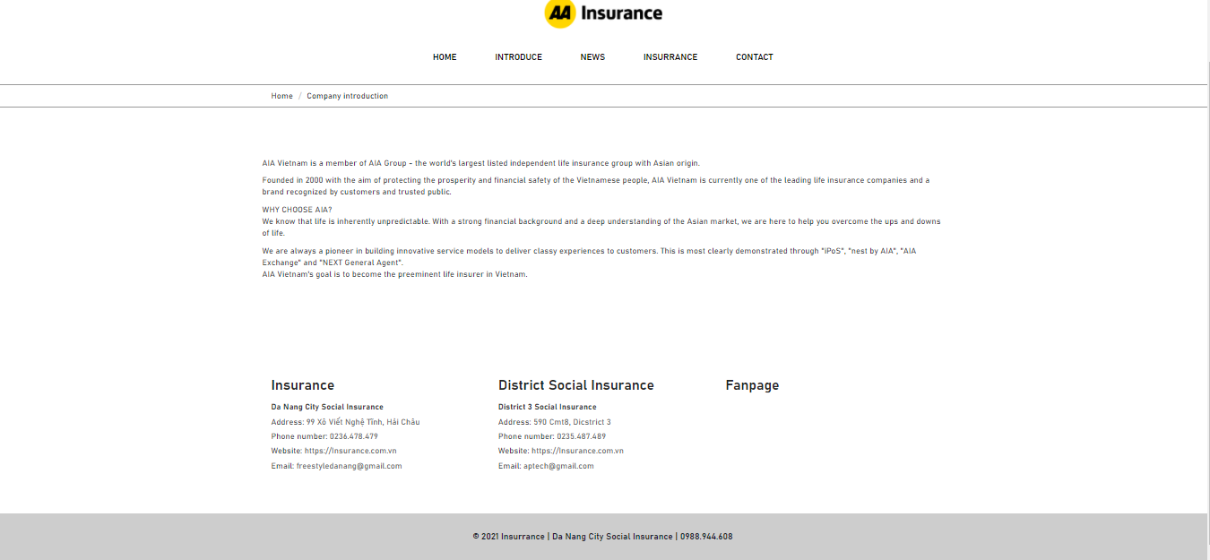

* 1. **New**

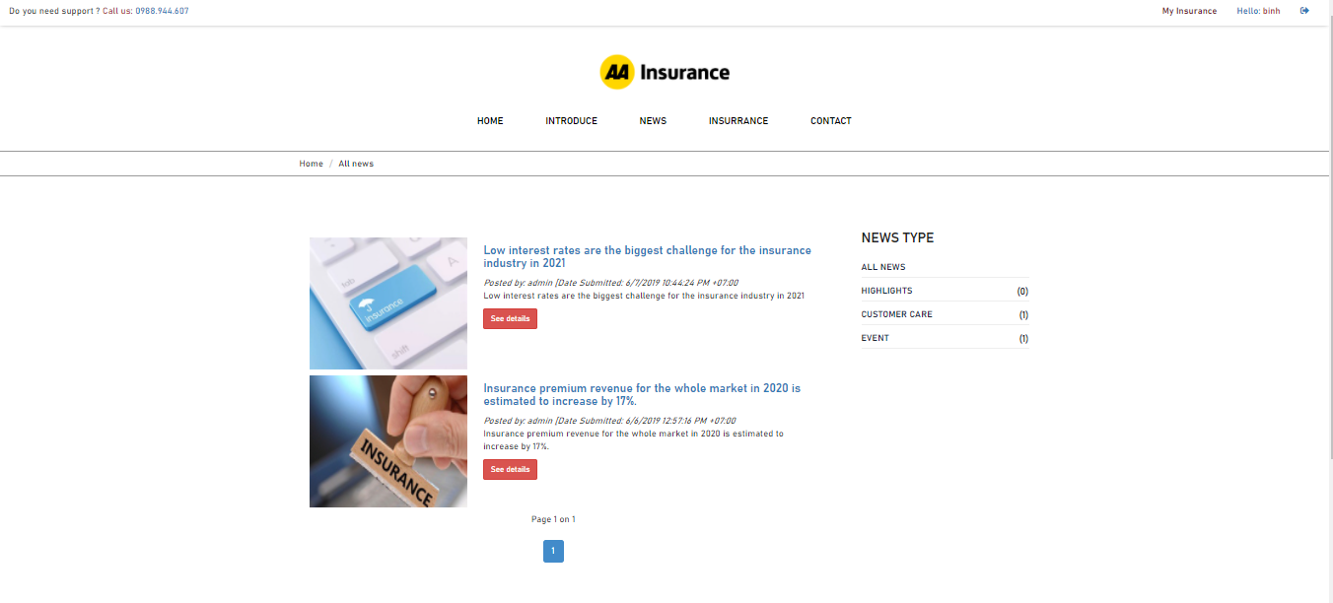

* 1. **Insurance**

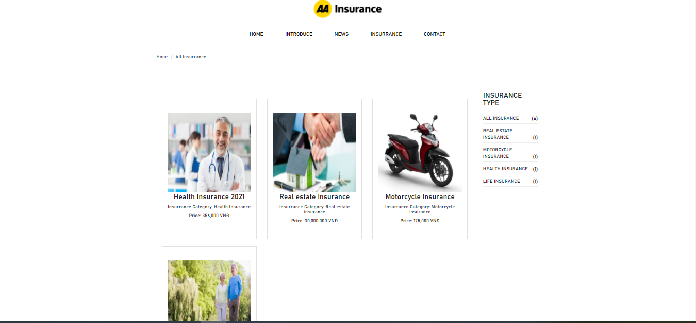

* + 1. **See Details**

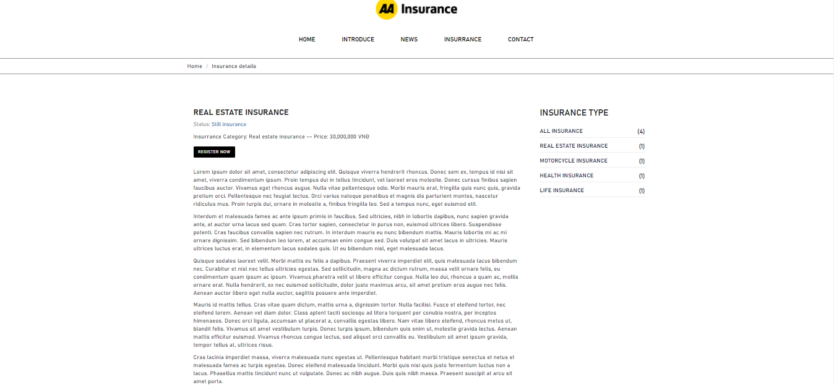

* + 1. **Registration Insurance**

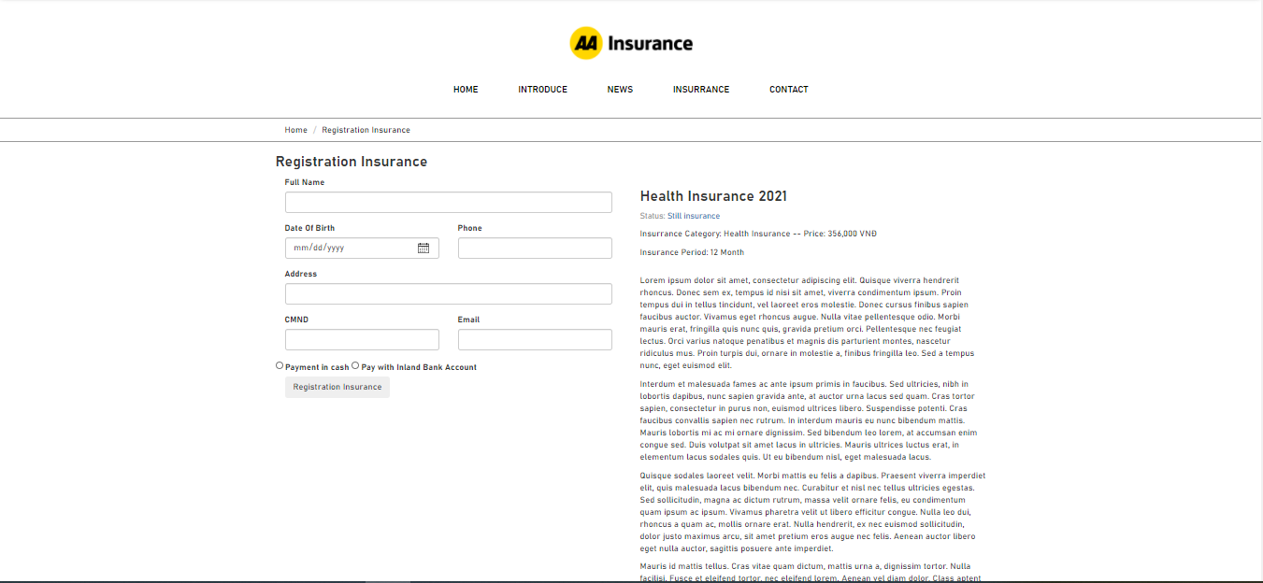

* + 1. **Online Payment**

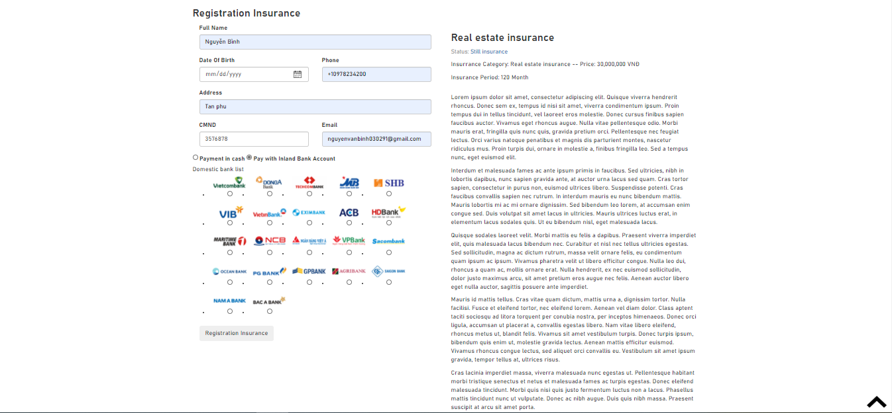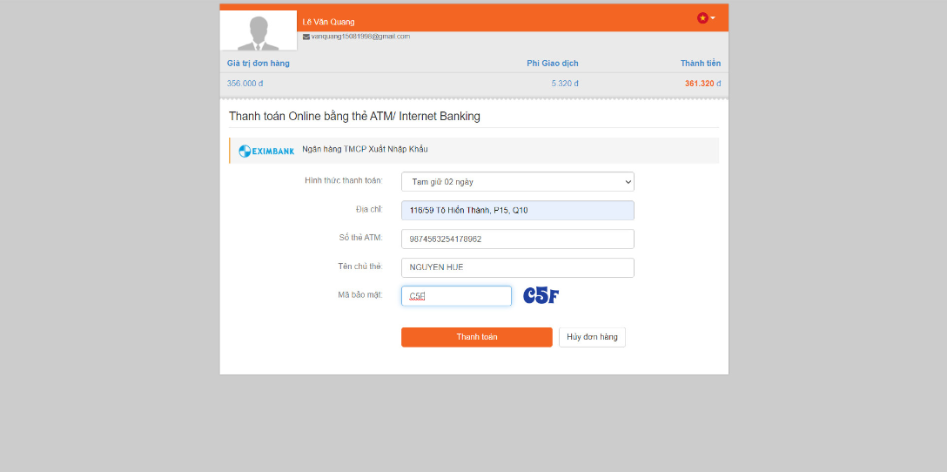

* 1. **Contact**
     1. **Feedback**

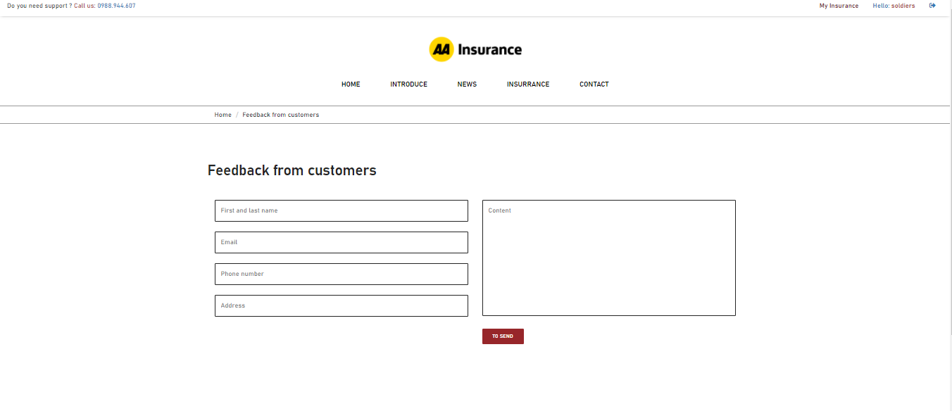

* + 1. **Feedback from customers**

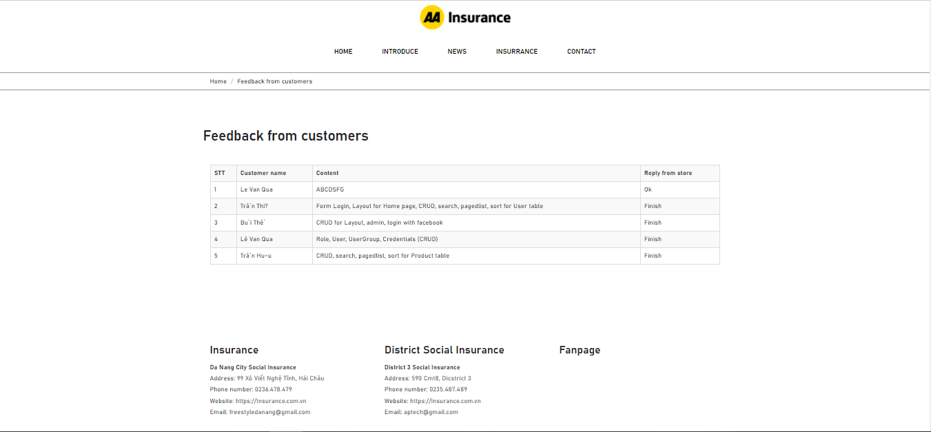

* 1. **Profile**

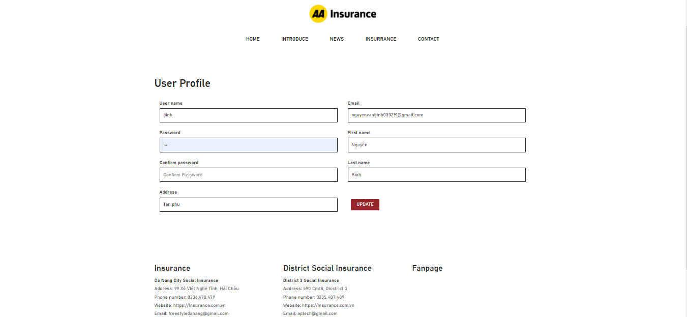

* 1. **Payment Email**

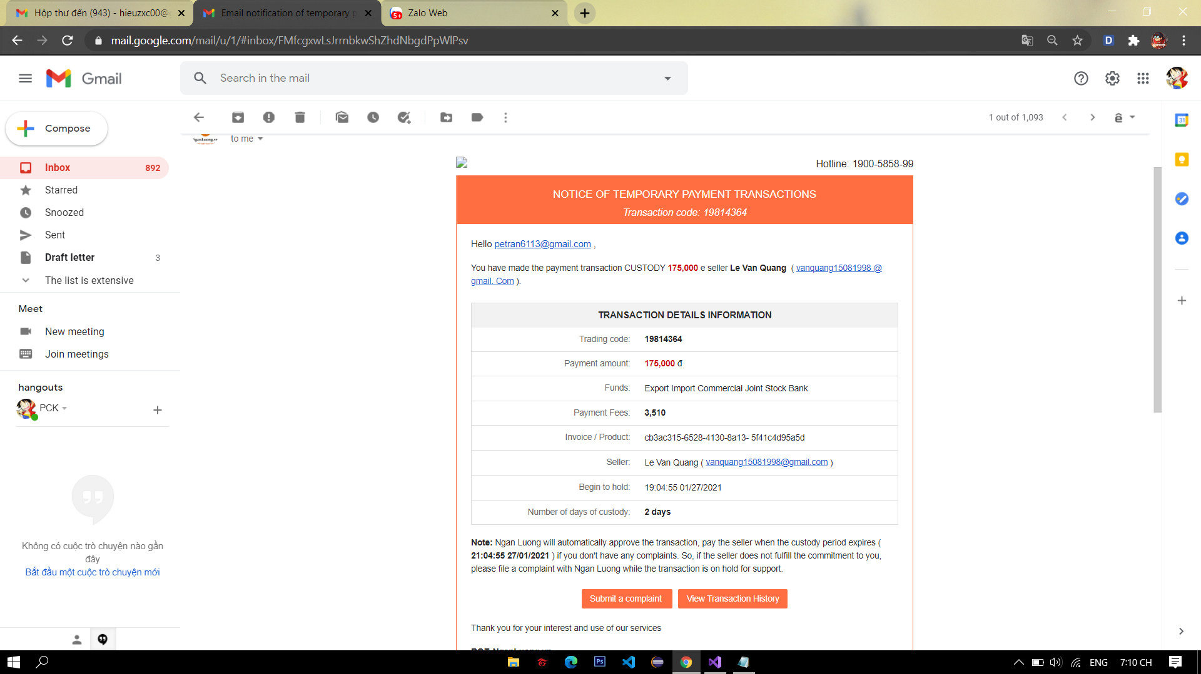

# 

# Task Sheet Review III

|  |  |  |  |  |  |
| --- | --- | --- | --- | --- | --- |
| Project Ref. No: 3 | Project Title:  Online Insurance Service | Date of Preparation of Activity Plan | | | |
| No. | Task | Actual Start Date | Actual Days | Team Member Names | Status |
| 01 | Database Diagram | Jan -20, 2021 | 5 | Nguyen Van Binh | Completed |
| 02 | Database Structure | Completed |
| 03 | * Clients list. * Edit clients details * Delete client * View Clients details. * Search Client List * Edit Status * Reply Client * Show a client reply | Le Minh Hieu | Completed |
| 04 | * Login. * Logout. * Admin index. * User list. * Create new User. * Edit User. * User details. * Delete User. | Nguyen Van Binh | Completed |
| 05 | * Insurance list. * Create new Insurance. * Edit Insurance. * Insurance details. * Delete Insurance. * Create new Insurance articles * Insurance Articles List * Edit Insurance articles * Delete Insurance articles | Pham Khoi Huan | Completed |
| 06 | * See Details Insurance. * Registration Insurance. * Online Payment. * Registration details. * Show Profile . * Edit Profile. * Create new User Group * Edit User Group * Delete User Group | Tran Duy Phu | Completed |

|  |  |  |
| --- | --- | --- |
|  | Prepare By: Group 5 | Approved By: Faculty |
| Date: Jan-20, 2021 | Team Leader  NGUYEN VAN BINH | Mr. NGO PHUOC NGUYEN |